**Assignment 6:**

**==============**

**A flow chart to show the single level and multilevel inheritance in Selenium (That which was discussed in the class)**

**\*\*Mention Keyword**

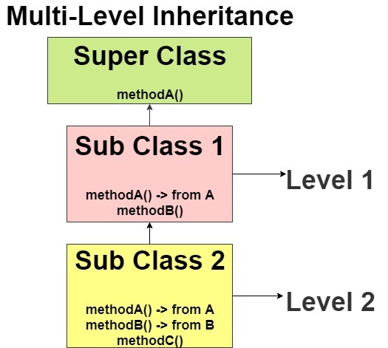**==================================================**

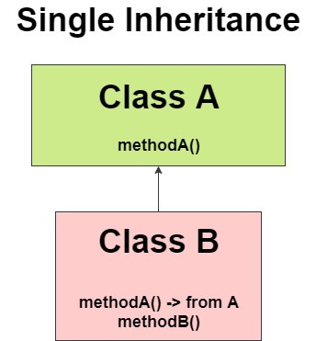

**Keyword**: extends

1. Child class – parent class
2. Derived class-base class
3. Sub class – super class

Father -> Grandfather – Single Inheritance.

Child -> Father - MultiLevel Inheritance.